**Test Case 1 – 2 Walls of Different Thicknesses with Parallel Aligned Faces**

*Test Description* : A 4-zone model that is similar to a real condition in commercial architecture where thinner partitions are connected to a thicker interior concrete shear wall. This test case spans two floors with an additional plenum zone on the first of the two levels.

This test is designed to make sure that when walls of different thicknesses are joined with their faces aligned, that the centerline offset does not create extra walls during the gbXML creation process.

*Space Names:* This is important because the gbXML validator requires the strings in the test file match the standard file. The name check is case sensitive. Ensure that the id attribute of the Space elements in the gbXML test file match

|  |  |  |
| --- | --- | --- |
| Standard File Space Name | Test File Space Name | Verified |
| sp-1-Space |  |  |
| sp-2-Space |  |  |
| sp-3-Space |  |  |
| sp-4-Space |  |  |

*Special Considerations:*

1. this test is not required for CAD/BIM authoring tools that produce gbXML without wall thicknesses geometrically defined.
2. Many BIM authoring tools currently do not properly define the interface where the two walls of different thickness join, creating what are known as ‘slivers’. This test specifically will not allow slivers to be created. The appearance of slivers will result in a failed test.

*Complexity of the BIM Model:*

1. Simple planar surfaces orthogonal to the project Cartesian reference frame.
2. Two wall thicknesses with faces aligned.
3. Simplified walls with no visible layers.
4. Simple details at interfaces of surfaces.

*Description of Test:*

Figure 1 details how the thinner walls are joined to the thicker walls and the alignment of the faces. In this case, the figure shows an instance of the north exterior wall of the occupied space meeting the north concrete shear wall and the interior shear wall. Figure 2 provides a basic schematic outline of a typical floor plan with dimensions that are relevant for the creation of gbXML spaces and surfaces. All levels have the same floor plan so this schematic view is only shown for a floor plan in this test case.

Figures 3, 4, and 5 show elevations, a 3D axonometric cutaway view, and a section cut that further define the relationship between the zones and their surfaces. In these diagrams there are tags that show the spaces as they have been named in this test case, for reference. Note that the western interior shear wall is a drawn in the BIM as a single interior wall but the wall must be subdivided to meet the requirements of a second level space boundary for energy modeling purposes.

Finally, the plenum zone is used to ensure that the thicknesses of both the floor slab and the plenum ceiling should be defined within the gbXML file’s Space 4 (sp-4-Space) node.

Thicker North exterior shear wall

Thinner North

exterior wall

Thicker interior shear wall

Thicker East exterior shear wall

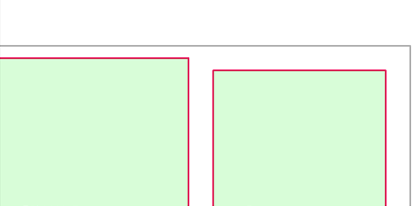

Shaft

Occupied Zone

Figure : Test case 1 addresses the issues specifically related to walls of different thicknesses, as seen in the image above.

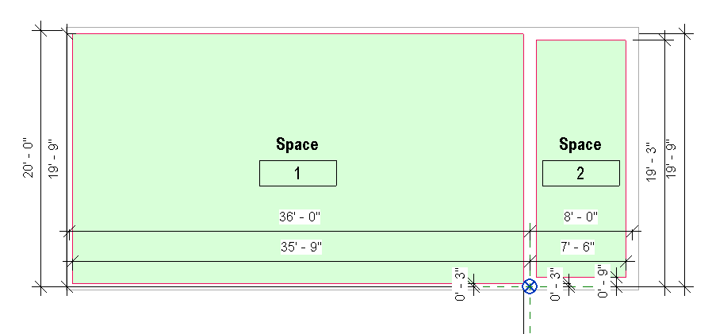

Figure : Typical Floor plan with dimensions important for the gbXML surface and space definitions. The origin of the projects is noted in this figure.

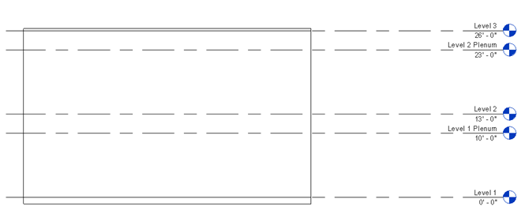

Figure : Elevation with the Z-height of each level in the project.

Western interior shaft wall

Thicker exterior shear wall (shaft location)

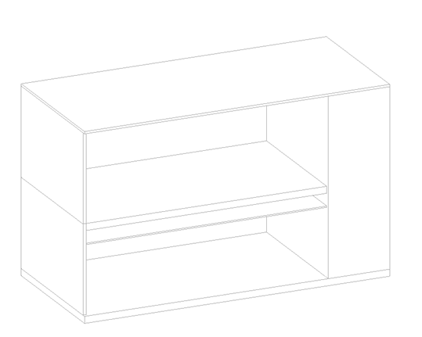

Space 2

(shaft)

Space 4 (plenum)

Space 3

Space 1

Slab-on-Grade

Plenum Ceiling

Floor Slab

ExteriorBrick Wall

Roof

Figure : 3-dimensional Isometric View of Test Case 1, with South Wall invisible to see cutout.

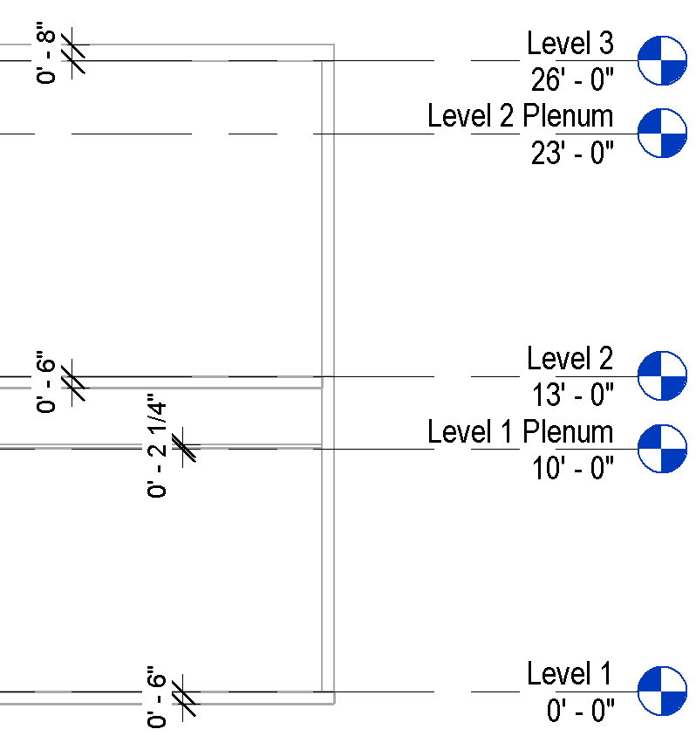

Figure : Positioning and dimensions of slab roof and plenum ceiling elements. Note there is no ceiling on the second floor.

|  |  |  |  |
| --- | --- | --- | --- |
| Wall Description | Wall Thickness | Wall Type | Comments |
| Thinner Exterior Wall | 6” |  |  |
| Thicker Interior Shear Wall | 12” |  |  |
| Thicker Exterior Shear Wall | 12” |  |  |

Table : Dimensions and descriptions of wall elements in Test Case 1.

*Example of the gbXML Code Relevant to this Example*

Interface of the thick and thin wall intersection:

<Space id = “sp-1-Space” … >

<ShellGeometry id=”sg-sp-1-Space” unit=”Feet”>

<ClosedShell>

…..

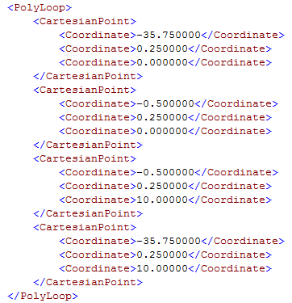

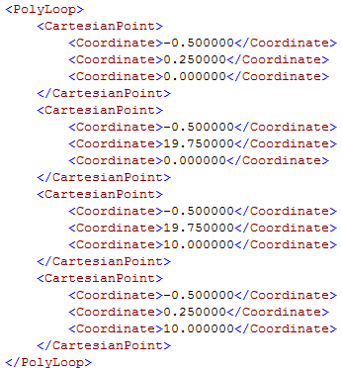

….

</ClosedShell>

</ShellGeometry>

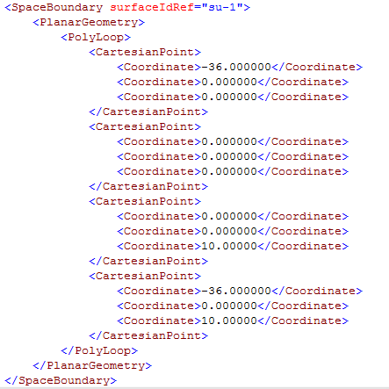

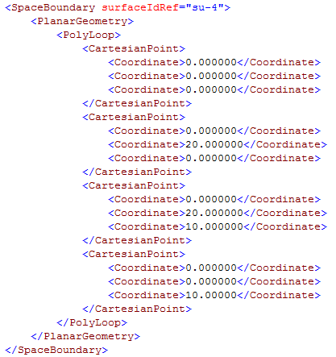

</Space>

<Space id = “sp-2-Space” … >

<ShellGeometry id=”sg-sp-2-Space” unit=”Feet”>

<ClosedShell>

…..

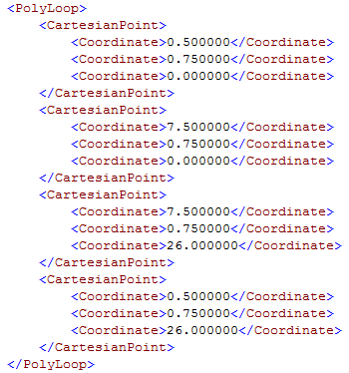

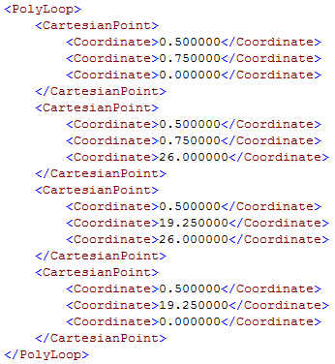

….

</ClosedShell>

</ShellGeometry>

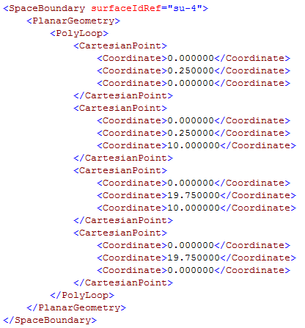

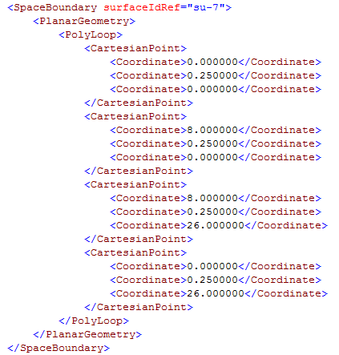

</Space>

